When saving quotevalet order I seem to get different templates. If its possible to have a different logo displayed depending on template chosen that would be great. If not a logo – just a reference to Avaya Cloud as per below.

Example of Telstra branded quotevalet quote

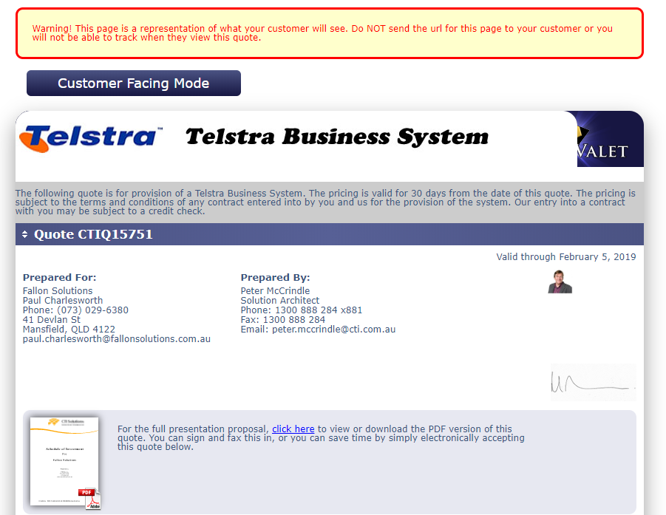

This is one of the Quotevalet Order Forms we have
https://www.quotevalet.com:443/OrderForm.aspx?TenantId=eef1c1ca-d496-4fb9-84f1-bdb41e11644a&DocumentId=d0713ba5-cb92-4524-a14b-05b7d26a36a0

There is another variant which allows user to add quantity and also support PO

Ideally one template which has all attributes and a second clone which shows Avaya Cloud Your Way ( as opposed to simply have CTI Logo.

Sold to and Ship To Address 1 and Ship 2 Address
PO Number
If Recurring amounts exist would be good to display both inc GST(TAX) and ex GST amounts.
1300 888 284 Telephone number displayed

https://www.quotevalet.com:443/OrderForm.aspx?TenantId=eef1c1ca-d496-4fb9-84f1-bdb41e11644a&DocumentId=d0713ba5-cb92-4524-a14b-05b7d26a36a0

